VIA UNIVERSITY COLLEGE

SOFTWARE ENGINEERING

Software Requirement

Specification

Food and Recipe Assistant

# Introduction

## Purpose

This SRS describes all requirements both functional and nonfunctional for the following bachelor project: Food and Recipe Assistant (FRA). This SRS will be used by the project team members and their supervisor as a guideline for planning and clarification. The implementation of these requirements is planned to be finished before the project deadline.

## Document Conventions

No special typographical conventions are used in this SRS.

## Project Scope

The scope of this project is to allow people with special diets to manage, share recipes and to monitor and maintain diets as well as to replace the overwhelming number of applications required to perform such tasks with a single solution. More details are available in the Bachelor Project Description of this project.

# Overall Description

## Product Perspective

Food and Recipe Assistant is a system that replaces current various applications related to food, diets and recipe management with a single online solution which will be implemented as web application and thus available on every device with internet browser. In later releases more features will be added, and the scope will be expanded. The following Context Diagram Figure 1 displays basic operations, external entities and system interfaces.

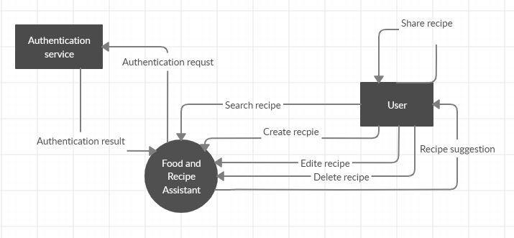

*Figure 1 System Context Diagram*

## User Classes and Characteristics

|  |  |
| --- | --- |
| **User class** | **Description** |
| User | Since this application has only one type of the user - User is any person using this application that profits from its functionalities. This user has access to all parts and functions of the application. User is expected to mainly manage / share recipes and receive suggestions / notifications from the system. |

## Operating Environment

**OE-1:**  The Food and Recipe Manager is a single page web application that will operate correctly in the following browsers:

* Google Chrome, v. 77.0
* Mozilla Firefox, v. 70.0

**OE-2:** The FRA is accessible from the internet

## Design and Implementation Constraints

**CO-1:** Front end will be responsive

**CO-2:** The communication between the server and client will be handled by REST services

## Assumptions and Dependencies

No dependencies have been identified.

# System Features

## Functional requirements

### FR-1 Register the user

The user shall create new user account by filling in the information required and submitting it. As a result, a new account shall be created and available to the user immediately.

Priority: High

**FR-1.1:** The user shall be able to create new user account by filling in the required information and submitting it.

### FR-2 Create recipe

The user shall be able to create a new recipe by filling in the required information. As a result, the recipe should be added to the list of existing recipes and more details shall be displayed when the recipe is selected from the list of recipes.

Priority: High

**FR-2.1:** The user should be able to add a new recipe by filling in the required information and submitting.

**FR-2.2:** New recipe should appear in the list of recipes immediately without the need to refresh the page.

**FR-2.3:** When the user selects the recipe from the list, more details should be displayed.

### FR-3 Edit recipe

The user shall be able to edit the existing recipes, specifically name, ingredients, description and picture by selecting new values for these fields.

Priority: High

**FR-3.1:** The user shall be able to update an existing recipe by providing new values.

### FR-4 Remove recipe

The user shall be able to remove an existing recipe. This action shall remove it from the view as well as delete it from the database permanently.

Priority: Medium

**FR-4.1:** The user shall be able to remove an existing recipe from his list of recipes.

**FR-4.2:** If the user shared this recipe with some of the other users - friend, it shall not be deleted from their lists.

### FR-5 Add friend

The user shall be able to add other users as „friends“ by entering their email address. If other users accept the request, they shall appear in the „Friends list“.

Priority: High

**FR-5.1:** The user shall be able to add other users as „friends“ by email address.

**FR-5.2:** The user should be able to confirm a friend request.

**FR-5.3:** The user should be able to reject a friend request.

**FR-5.4:** If the fried request is confirmed, users should be able to mutually see each other in their „Friend lists “.

### FR-6 Share a recipe with friend

The user shall be able to share the recipes with other users from his „ Friend list “. The other user then can see the recipe and add it to his recipes if desired.

Priority: High

**FR-6.1:** The user shall be able to send a recipe to other users from his „ Friend list “.

### FR-7 Search in recipes

The user shall be able to search in the list of his recipes by some search criteria specifically name of the recipe, ingredient or category.

Priority: High

**FR-7.1:** The user shall be able to search in the list of recipes by the recipe name.

**FR-7.2:** The user shall be able to search in the list of recipes by the ingredient.

**FR-7.3:** The user shall be able to search in the list of recipes by the category.

### FR-8 Recipe suggestion

The user shall have an option to get a recipe suggestion. This action shall be followed by a recipe suggestion based on the previous recipe choices of the user.

Priority: High

**FR-8.1:** The user shall be able to get a recipe suggestion.

### FR-9 Shopping list

The user shall be able to add items to the shopping list directly from the list of ingredients of a recipe. The added ingredient shall be visible in the shopping list with possibility to be removed.

Priority: Low

**FR-9.1:** The user shall be able to add items to the shopping list directly from the list of ingredients of a recipe.

**FR-9.1:** The user shall be able to remove items from the shopping list.

### FR-10 Notifications

The user shall receive notifications about the friend request or when a recipe from the friend is received.

Priority: High

**FR-10.1:** The user shall be able to receive notifications about friend requests.

**FR-10.2:** The user shall be able to receive a notification about recipes received from friends.

## Non-functional requirements

**NFR-1:** The application should be independent of the operating system of the device.

**NFR-2:** Client should have a responsive character.

**NFR-3:** The response time of the system should be less than 3 seconds 90% of the time.

**NFR-4:** The time to learn and operate the system shall be below 15 minutes.

**NFR-5:** Menu of the system should be designed for easy use on touch screens.

**NFR-6:** System language shall be English as it is most widely spoken world language.

# Data Requirements

## Logical Data Model

Figure 2 – Data Model of the system displays a very simplified version of the relations of the most important data in the system. The foundation is a user and recipes. The rest of the system shall be built on top of it. Second most important is the ingredient entity which holds information like energy value etc. which is significant for some functionalities of the system. Third relation depictured is a relationship between two users. This allows the user to have “friends” and thus gives them the option to share recipes with them.

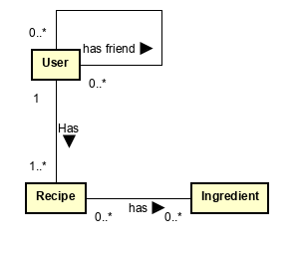

*Figure 2 Partial Data Model of system*

## Data Dictionary

|  |  |  |  |
| --- | --- | --- | --- |
| **Data element** | **Description** | **Composition of data type** | **Length values** |
| Recipe name | Unique name of recipe | Alphabetic | Max 50 |
| Recipe information | * Name * Description * Ingredients | Alphanumeric |  |
| User | * Name * Email – must be unique * Password | Alphanumeric | Name: Max 20 |
| Ingredient | * Unique name * Energetic value | Alphanumeric |  |

# External Interface Requirements

## User Interfaces

**UI-1:** The UI shall be responsive with desktop first approach.

**UI-2:** The UI shall be adjusted for mobile devices.

**UI-3:** The UI shall be adjusted for touchscreens.

## Software Interfaces

**SI-1:** Food and recipe assistant

**SI-2:** Notification Service

## Hardware Interfaces

No hardware interfaces have been identified

## Communications Interfaces

**CI-1:** FRA shall send notifications when a new recipe is received from a friend.

# Quality Attributes

## Security Requirements

**SCR-1:** All users information such as email etc. shall be hidden from other users – only if user permits.

**SCR-2:** Users do not have access to the application if not logged in.

# 7. References and expected sources

Anon 2019. *World language - Wikipedia*. [online] Available at: <https://en.wikipedia.org/wiki/World_language> [Accessed 8 Nov. 2019].